Title: Landscape differences among cities alter species’ responses to urbanization

**Authors:** Mason Fidino1*, Travis Gallo2, Elizabeth W. Lehrer1, Maureen H. Murray1, Cria Kay1, Heather A. Sander3, Brandon MacDougall3, Carmen M. Salsbury4,5,Travis J. Ryan4,5, Julia L. Angstmann5, J. Amy Belaire6, Barbara Dugelby7, Chris Schell8, Theodore Stankowich9, Max Amaya9, David Drake10, Sheryl H. Hursh11, Adam A. Ahlers12, Jacque Williamson13, Laurel M. Hartley14, Amanda J. Zellmer15,16, Kelly Simon17, Seth B. Magle1

**Affiliations:**

1Department of Conservation and Science, Lincoln Park Zoo, Chicago, Illinois, 60614, USA

2Department of Environmental Science and Policy, George Mason University, Fairfax, Virginia, 22030, USA

3Department of Geographical and Sustainability Sciences, University of Iowa, Iowa City, Iowa, 52240, USA

4Department of Biological Sciences, Butler University, Indianapolis, Indiana, 46208, USA

5Center for Urban Ecology and Sustainability, Butler University, Indianapolis, Indiana, 46208, USA

6The Nature Conservancy, Austin, Texas, 78701, USA

7Wild Basin Creative Research Center, St. Edward’s University, Austin, Texas, 78704, USA

8Interdisciplinary Arts and Sciences, University of Washington Tacoma, Tacoma, Washington, 98405, USA

9Department of Biological Sciences, California State University, Long Beach, California, 90840 USA

10Department of Forest and Wildlife Ecology, University of Wisconsin-Madison, Madison, Wisconsin, 53706, USA

11Nelson Institute, University of Wisconsin-Madison, Madison, Wisconsin, 53706, USA

12Department of Horticulture and Natural Resources, Kansas State University, Manhattan, Kansas, 66506, USA

13Department of Education & Conservation, Brandywine Zoo, Wilmington, Delaware, 19802, USA

14University of Colorado Denver, Denver, Colorado, 80217, USA

15Department of Biology, Occidental College, Los Angeles, California, 90041, USA

16Arroyos and Foothills Conservancy, Pasadena, California, 91102, USA

17Texas Parks and Wildlife Department, Austin, Texas, 78774, USA

*Correspondence to: [mfidino@lpzoo.org](mailto:mfidino@lpzoo.org)

**Abstract:** Predicting how wildlife respond to urbanization is challenging, due in part to the single-city focus of most urban ecological research. Here, we delineate continent-scale patterns in urban species assemblages by leveraging data from a multi-city biodiversity survey and quantify how differences in greenspace availability and average housing density among ten North American cities relate to the distribution of eight widespread North American mammals. The magnitude and direction of most species' responses to urbanization within a city were associated with landscape-scale differences among cities. Further, species richness consistently declined with urbanization in more densely developed cities. Given our results, it may therefore be possible to design cities to better support biodiversity and reduce the negative influence of urbanization on wildlife.

**One Sentence Summary:** How green and densely populated a city is can predict where wildlife live in cities.

**Main Text:**

More people live in cities than in rural areas worldwide (*1*). To meet the demands of their human inhabitants, cities are expanding in area commensurate to roughly twice their population growth rate (*2*). This urban expansion drives global environmental change and threatens biodiversity (*1,3*). And although some species can inhabit and possibly thrive in cities (*4*) explorations into their urban ecology were historically rare and have only increased in recent decades (*5-7*). Despite these increased levels of urban ecological research there is still much to understand about how urbanization influences Earth’s ecology.

Most urban ecological studies focus on a single city, which limits our understanding of urban areas as ecosystems (*8*). Single-city research can identify ecological responses to local patterns of urban development, but these responses cannot be extrapolated to other cities that differ in age, size, climate, or human population density, among other variables (*8-10*). Current multi-city assessments, for example, show that differences in bird and plant richness among cities are correlated with among-city differences in land-cover and age (*11*). Likewise, the location of water bodies or railways within a city can facilitate or hinder movement between wildlife populations and therefore influence where in a city that species may persist (*12*). As a result, a single species may respond to urbanization in different ways among cities. Multi-city comparative approaches are therefore necessary to understand whether species’ responses to urbanization are generalizable across cities, or if they vary due to landscape-scale differences among cities (*8,11-12*). Such assessments, however, remain challenging because few coordinated efforts monitor biodiversity in multiple cities.

Here we show how landscape-scale differences among cities influence the within-city distribution of urban-adapted mammals by leveraging data collected by the Urban Wildlife Information Network (UWIN; www.urbanwildlifeinfo.org) – a systematic multi-city biodiversity monitoring survey (*8*). Our goals were to determine if the distribution and richness of terrestrial mammals within cities changed as a function of among-city differences in 1) greenspace availability and 2) average housing density. These two landscape-scale metrics are respectively associated with the average habitat potential in a city and its intensity of urbanization, which may collectively indicate the overall quality of a city as habitat for a species (*8,10*). We predicted that the expected proportion of habitat patches a species occupies within a city (i.e., the relative occupancy of a species) would increase in cities with more greenspace but decrease in cities with higher average housing density. Likewise, we predicted that within cities, species would exhibit a stronger negative response to urbanization (i.e., be less likely to occur closer to an urban core) in cities with higher average housing density or less greenspace. We advance previous multi-city biodiversity assessments by quantifying whether the magnitude and direction of a species’ response to urbanization changes due to landscape-scale differences among cities. This unique approach allows us to begin to identify the degree to which results from a single city can generalize to other cities or if species’ responses to urbanization are unique to individual cities.

**Results**

A total of 25,115 camera trap nights occurred from 808 camera deployments at 569 sites across the 10 US cities (Fig. S1, Table S1). Eight species had enough data to analyze, representing a common suite of urban-adapted, medium-to-large mammals throughout North America: raccoon (*Procyon lotor*, 5504 detections across 10 cities), eastern gray squirrel (*Sciurus carolinensis*, 2465 detections across 6 cities), Virginia opossum (*Didelphis virginiana*, hereafter opossum, 2210 detections across 7 cities), cottontail rabbit (*Sylvilagus floridanus* or *Sylvilagus audubonii*, hereafter cottontail, 1731 detections across 9 cities), fox squirrel (*Sciurus niger*, 1508 detections across 8 cities), coyote (*Canis latrans*, 821 detections across 9 cities), striped skunk (*Mephitis mephitis*, 548 detections across 9 cities), and red fox (*Vulpes vulpes*, 368 detections across 8 cities). For a summary of the range and extent of within and among-city covariates see Supplemental material.

**Model selection**

Model selection results indicated that differences in the urban form of cities were associated with the within-city habitat dynamics of all but one species, the striped skunk (Table 1). The global model (*Mglobal*) was the best fit model for gray squirrel, the housing model (*Mhousing*) for coyote, opossum and raccoon, and the greenspace model (*Mgreenspace*) for cottontail, fox squirrel, and red fox (Table 1; Fig. 1).

**Changes in average occupancy associated with differences among cities**

The average occupancy of raccoon and cottontail were influenced by differences among cities (Fig. 2A). Raccoon occupancy was highest in cities with a low average housing density (Figure 2A, $γ_{02, raccoon}$ = -0.58, 95% CI = -1.18 - -0.01). Overall, raccoon had the highest average occupancy (i.e., the most positive intercept, Fig. 1A). There was some evidence that cottontail relative occupancy decreased in cities with more greenspace (Fig. 2B, $γ_{02, cottontail}$ = -0.22, 95% CI = -0.49 – 0.03).

**Species-specific responses to urbanization within a city associated with differences among cities**

Fox squirrel, gray squirrel, and red fox responses to urbanization, which we estimated as their log-odds changes in occupancy due to differences in site-level housing density, changed as a function of greenspace availability in a city (Fig. 1B). When greenspace availability in a city was less than 19.70% (95%CI = 16.90 - 22.69) fox squirrels responded negatively to urbanization and were less likely to occupy sites surrounded by high levels of housing density within a city (Figure 3A). Conversely, fox squirrel responded positively to site-level housing density if greenspace availability in a city was greater than 19.70% (Fig. 3A). Gray squirrel and red fox followed a similar pattern and both species responded positively to site-level housing density in cities that had more greenspace (~28% for both species; Fig. 3B-C).

The among-city response to urbanization of coyote, opossum, and raccoon changed as a function of a city’s average housing density (Fig. 1B). Opossum and raccoon responded negatively to site-level housing density in densely populated cities (Fig. 4A-B). For example, Chicago had the highest average housing density (1316.70 houses km-2) and there was strong evidence that raccoon and opossum responded negatively to site-level housing density in Chicago ($β_{Chicago,raccoon}$ = -0.55, 95% CI = -0.77 - -0.35; $β_{Chicago,opossum}$ = -0.56, 95% CI = -0.80 - -0.33). However, raccoon and opossum responded positively to urbanization in cities with a low average housing density (Fig. 4A-B). Manhattan, Kansas had the lowest average housing density (313.35 houses km-2) and there was some evidence that raccoon and opossum responded positively to site-level housing density in that city ($β_{Manhattan,raccoon}$ = 0.41, 95% CI = -0.34 - 1.18; $β_{Manhattan,opossum}$ = 0.27, 95% CI = -0.37 - 0.92). Thus, the spatial distribution of raccoon and opossum within a city varied depending on a city’s average housing density. Coyote, however, always responded negatively to site-level housing density in a city, but the strength of this effect was reduced in more densely populated cities (Fig. 4C). Thus, although coyote were most likely to occur at sites near less populated areas, this relationship was strongest in sparsely populated cities.

**Species richness within and among cities**

The cumulative effect of among-city differences in greenspace availability and average housing density resulted in altered mammal community composition and diversity (Fig. 5). Across all cities, sites with less-than-average housing density had a mean of 3.17 mammal species from this study (95% CI = 0 - 6), while sites with more-than-average housing density had 2.84 (95% CI = 0 - 6). For cities with more than 710 houses km-2 on average, species richness was consistently lower at sites surrounded by greater than average housing density (Fig. 5). Of species we analyzed, the raccoon was lost most often from the wildlife community as the average housing density increased in a city. Within-city differences in species richness were equivocal for cities with an average housing density less than or equal to 710 houses km-2 and could be positive, negative, or unchanged.

**Discussion**

This analysis clearly demonstrates associations between landscape-scale differences among cities and changes in the magnitude and, at times, the direction of species’ responses to urbanization. Within-city distributions of gray squirrel, fox squirrel, and red fox, for example, were associated with differences in greenspace availability among cities (Fig. 3). Within-city distributions of coyote, opossum, and raccoon varied with the average housing density of a city (Fig. 4). If these data were analyzed as independent single-city studies we would infer dissimilar species-specific responses to urbanization (Fig. 1). Analyzing them together, as we have done here, allows us to see that these apparent disagreements are explained by landscape-scale differences among cities. Most importantly, these results indicate that generality is possible between cities that are similar, for example, cities that have similar average housing densities. To facilitate cross-study syntheses and allow for a broader understanding of urban wildlife it is therefore imperative that future urban ecological research describe the broader context of urbanization within a city.

We described each city’s broader context of urbanization with two metrics: the proportion of greenspace and the average housing density of a city. While simple, these metrics described the habitat potential, or lack thereof, within a city and were correlated with differences in how species respond to urbanization (Fig. 1). These metrics were also correlated with among-city changes in average occupancy of raccoon and cottontail. The average occupancy of raccoon decreased in cities with higher average housing density (Fig. 2A) and cottontail occupancy was lower in cities with more greenspace (Fig. 2B). This latter relationship was contrary to our prediction that greenspace availability would positively influence species occupancy. It is possible that additional greenspace within a city increased the presence of predators and therefore constricted cottontail distributions (*13*). Although the importance of scale is well recognized in ecology (*14-16*), the single-city focus of past urban ecological research prevented explorations into how landscape-scale differences influence urban ecological phenomena. Yet, as we have begun to show here, there is a need to explore how variables at the city-scale or larger drive species’ distributions within and among cities (*8,11,17*).

For vertebrates, increased urbanization generally results in decreased species richness at the local scale (*18-20*). In our analysis, cities with an average housing density greater than 710 housing units km-2 (n = 3) consistently lost species at the local scale with increasing urbanization (Fig. 5), which validates this pattern. Conversely, species richness either increased (n = 3), decreased (n = 1), or did not change (n = 2) along the urbanization gradient of less densely built cities (Fig. 5). To our knowledge, no studies have explored how landscape-scale variables may explain why such a pattern is observed in one city but not another. As the Earth urbanizes and cities increase in size and population density (*2*), our results indicate that larger cities are more likely to observe diversity losses of common species, which may have dramatic consequences on ecosystem function (*21*). As such, it may be imperative for growing cities to find innovative solutions to reduce the likelihood of local extinctions and bolster wildlife resilience.

A core feature of our analysis is that the results can be used to develop quantitative and testable predictions for how common urban species are distributed throughout any city where they are known to exist or may exist in the future. Since some species’ average occupancy (Eq. S2) and responses to urbanization (Eq. S3) are a function of landscape-scale variables, species distributions can be easily estimated within cities that vary in greenspace availability and average housing density. Given current levels of global change, there is great need for increased predictive power in ecology (*22*), especially as it is simpler to manage a system’s ecological characteristics if they are predictable (*23*). As we live in an increasingly urban world, it is not only essential to understand and predict how biodiversity responds to urbanization, but also to identify ways to advance urban conservation and reduce the negative impacts of urbanization on biodiversity. While we expect deviations from our model predictions, such discrepancies are welcome as they likely point to other landscape-scale variables that influence species distributions or could possibly highlight within-city species adaptations. For example, we simplified each city’s urbanization gradient and represented it with a single metric: the housing density within 1000 m of each camera trap. As urbanization is inherently composed of multiple variables (*24*), and there may be significant urbanization with low housing density (e.g., industrial or commercial districts), discrepancies from our model predictions may indicate other urban metrics that are important predictors of species’ responses to urbanization. Likewise, the connectivity among habitat patches within a city may also relate to shifts in species distributions among cities (*12*), though such metrics are notoriously difficult to quantify in urban settings given that species persist within the urban matrix (*25-26*).

Although cities are the hallmark of urbanization, they each have their own structural signature penned by land-use policy, coastlines or inland waterways, and topography (*8,27*). It is a promising finding that species occupancy patterns are associated with differences among cities because it implies that growing cities can be planned in such a way to reduce the negative influence of urbanization on biodiversity. Other research has also shown that increasing greenspace generally increases biodiversity (*12*). We found that this may particularly be the case for tree squirrels and red fox (Fig. 3), as increasing greenspace within a city reduced the negative influence of urbanization on these species (Fig. 3). The positive benefits of green cities go beyond wildlife as urban greenspace also improves human health and wellbeing (*28-30*) and contributes to reduced urban heat island effects, better stormwater management, and cleaner air (*31*). As a result, urban greening is an opportunity for cities to simultaneously benefit their human and non-human inhabitants.

However, it is also crucial to recognize urban greening as an environmental justice issue (*32*). Communities of color disproportionately live in parts of a city where green space is either deficient or poorly maintained (*33*) and are marked by significant environmental legacies (e.g., persistence of lead in urban soils, *34*). Furthermore, while adding greenspace to these locations increases public health and neighborhood attractiveness, it can also displace the residents that the greenspace was meant to benefit via gentrification (*32*). Equitably increasing access to greenspace, and thus biodiversity, in a city therefore requires appropriate regulation and anti-gentrification policy which would, in turn, increase public health and advance social-environmental justice for urban communities (*27,32,35*). To illustrate the effectiveness of such policies, data will be necessary. As such, multi-city wildlife assessments could provide such data for cities to evaluate the potential impacts of regulation and policy on biodiversity, taking into account the desired outcomes of communities directly impacted by such changes.

In this paper, we demonstrate that species’ responses to urbanization depend on the form and function of the city where they occur. Likewise, we illustrate that generality is possible between cities that are structurally similar. For cities that are structurally dissimilar, a given species’ response to urbanization may even be in opposing directions (Fig. 3, Fig. 4). Our results highlight the critical importance of considering the broader context of urbanization in urban ecological research given that differences between single-city findings may be a function of landscape-scale differences among cities. Most importantly, because species respond to the form and function of a city, it may be possible to design cities to decrease the negative influence of urbanization on biodiversity. Achieving this goal at broad scales requires us to understand and predict how variability within and among cities influences ecological phenomena. This understanding will, in turn, require multi-city collaborative approaches to tease apart how factors at varying scales influence Earth’s urban biodiversity.

References and Notes:

1. K. C. Seto, B. Güneralp, L. R. Hutyra, Global forecasts of urban expansion to 2030 and direct impacts on biodiversity and carbon pools. *Proc. Natl. Acad. of Sci.* ***149*,**16083-16088 (2012).
2. S. Angel, J. Parent, D. L. Civco, A. Blei, D. Potere, The dimensions of global urban expansion: estimates and projections for all countries, 2000 – 2050. *Prog. Plann*. ***75****,*53-107 (2011).
3. N. B. Grimm *et al.*, Global change and the ecology of cities. *Science.* ***319****,* 756-760 (2008).
4. M. A. Goddard, A. J. Dougill, T. G. Benton, Scaling up from gardens: biodiversity conservation in urban environments. *Trends Ecol. Evol.* ***25***, 90-98 (2010).
5. S. B. Magle, V. M. Hunt, M. Vernon, K. R. Crooks, Urban wildlife research: past, present, and future. *Biol. Conserv.* ***155***, 23-32 (2012).
6. T. McPhearson, S. T. Pickett, N. B. Grimm, J. Niemalä, M. Alberti, T. Elmqvist, C. Weber, D. Haase, J. Breuste, S. Qureshi, Advancing urban ecology towards a science of cities. *BioScience.* ***66***, 198-212 (2016).
7. M. Fidino, S. B. Magle, “Trends in long-term urban bird research” in *Ecology and Conservation of Birds in Urban Environments*, E. Murgui, M. Hedblom, Eds. (Springer, 2017), chap. 9.
8. S. B. Magle *et al.*, Advancing urban wildlife research through a multi-city collaboration. *Front. Ecol. Environ.* ***17***, 232-239 (2019).
9. C. E. Ramalho, R. J. Hobbs, Time for a change: dynamic urban ecology. *Trends Ecol. Evol.* ***27***, 179-188 (2012).
10. M. F. Aronson *et al.,* Hierarchical filters determine community assembly of urban species pools. *Ecology*. ***97***, 2952-2963 (2016).
11. M. F. Aronson *et al.,* A global analysis of the impacts of urbanization on bird and plant diversity reveals key anthropogenic drivers. *P. Roy. Soc. B-Biol. Sci.* ***281***, 20133330 (2014).
12. J. Beninde, M. Veith, A. Hochkirch, Biodiversity in cities needs space: a meta-analysis of factors determining intra-urban biodiversity variation. *Ecol. Lett.* ***18***, 581-592 (2015).
13. K. R. Crooks, Relative sensitivities of mammalian carnivores to habitat fragmentation. *Conserv. Biol.* ***16***, 488-502 (2002).
14. J. A. Wiens, Spatial scaling in ecology. *Func. Ecol.* ***3***, 385-397 (1989).
15. S. A. Levin, The problem of pattern and scale in ecology: the Robert H. MacArthur award lecture. *Ecology.* ***73***, 1943-1967 (1992).
16. D. C. Schneider, The rise of the concept of scale in ecology: the concept of scale is evolving from verbal expression to quantitative expression. *BioScience.* ***51***, 545-553 (2001).
17. R. Steenweg *et al.,* Scaling-up camera traps: monitoring the planet’s biodiversity with networks of remote sensors. *Front. Ecol. Environ.* ***15***, 26-34 (2017).
18. M. L. McKinney, Effects of urbanization on species richness: a review of plants and animals. *Urban Ecosyst.* ***11***, 161-176 (2008).
19. M. Pautasso, Scale dependence of the correlation between human population presence and vertebrate and plant species richness. *Ecol. Lett.* ***10****,* 16-24(2007).
20. M. A. Ordeñana *et al.,* Effects of urbanization on carnivore species distribution and richness. *J. Mammal.* ***91***, 1322-1331 (2010).
21. K. J. Gaston, Valuing common species. *Science*. ***327***, 154-155 (2010).
22. V. Maris, P. Huneman, A. Coreau, S. Kéfi, R. Pradel, V. Devictor, Prediction in ecology: promises, obstacles, and clarifications. *Oikos.* ***127***, 171-183 (2018).
23. M. C. Dietze, *Ecological Forecasting*(Princeton University Press, Princeton, NJ, 2017).
24. R. J. Moll, J. D. Cepek, P. D. Lorch, P. M. Dennis, E. Tans, T. Robinson, J. J. Millspaugh, R. A. Montgomery, What does urbanization actually mean? A framework for urban metrics in wildlife research. *J. Appl. Ecol.* ***56***, 1289-1300 (2019).
25. E. C. Anderson, E. S. Minor, Vacant lots: an unexplored resource for ecological and social benefits in cities. *Urban For. Urban Gree.* ***21***, 146-152 (2017).
26. K. Soanes, M. Sievers, Y. E. Chee, N. S. Williams, M. Bhardwag, A. J. Marshall, K. M. Parris, Correcting common misconceptions to inspire conservation action in urban environments. *Conserv. Biol.* ***33***, 300-306 (2019).
27. L. Bounoua, J. Nigro, P. Zhang, K. Thome, A. Lachit, Mapping urbanization in the United States from 2001 to 2011. *Appl. Geog.* ***90***, 123-133 (2018).
28. C. Twohig-Bennett, A. Jones, The health benefits of the great outdoors: a systematics review and meta-analysis of greenspace exposure and health outcomes. *Environ. Res.* ***166***, 628-637 ***(2018).***
29. G. N. Bratman, C. B. Anderson, M. G. Berman, B. Cochran, S. De Vries, J. Flanders, C. Folke, H. Frumkin, J. J. Gross, T. Hartig, P. H. Kahn, Nature and medical health: an ecosystem service perspective. *Sci. Adv.* ***5***, p.eaax0903 (2019).
30. D. Rojas-Rueda, M. J. Nieuwenhuijsen, M. Gascon, D. Perez-Leon, P. Mudu, Green spaces and mortality: a systematic review and meta-analysis of cohort studies. *Lancet Planet Health.* ***3***, e469-e477 (2019).
31. E. Gómez-Baggethun, D. N. Barton, Classifying and valuing ecosystem services for urban planning. *Ecol. Econ.* ***86***, 235-245 (2013).
32. J. R. Wolch, J. Byrne, J. P. Newell, Urban greenspace, public health, and environmental justice: the challenge of making cities ‘just green enough’. *Landscape Urban. Plan.* ***125***, 234-244 (2014).
33. A. Rigolon, A complex landscape of inequity in access to urban parks: a literature review. *Landscape Urban. Plan.* ***153***, 160-169 (2016).
34. D. Morrison, Q. Lin, S. Wiehe, G. Liu, M. Rosenman, T. Fuller, J. Wang, G. Filippelli, Spatial relationships between lead sources and children’s blood lead levels in the urban center of Indianapolis (USA). *Environ. Geochem. Health.* ***35***, 171-183 (2013).
35. M. Kennedy, P. Leonard, “Dealing with neighborhood changes: a primer on gentrification policy choices,” (Brookings Institution Center on Urban and Metropolitan Policy and PolicyLink, 2001).
36. S. D. Gehrt, S. P. D. Riley, B. L Cypher, Eds., *Urban Carnivores: Ecology, Conflict, and Conservation* (JHU Press, Baltimore, MD, 2010).
37. J. S. Ivan, E. S. Newkirk, CPW photo warehouse: a custom database to facilitate archiving, identifying, summarizing and managing photo data collected from camera traps. *Methods Ecol. Evol.* ***7***, 499-504 (2016).
38. M. Fidino, uwinr. *Zenodo*. http://doi.org/10.5281/zenodo.1174244 (2018).
39. D. I. MacKenzie, J. D. Nichols, J. A. Royle, K. H. Pollock, L. Bailey, J. E. Hines, *Occupancy Estimation and Modeling: Inferring Patterns and Dynamics of Species Occurrence* (Elsevier, Amsterdam, Netherlands, 2017).
40. B. R. Pickard, J. Daniel, M. Mehaffey, L. E. Jackson, A. Neale, EnviroAtlas: a new geospatial tool to foster ecosystem services science and resource management. *Ecosyst. Serv.* ***14****,* 44-55 (2015).
41. J. L. Yang *et al.*, A new generation of the United States National Landcover Database: requirements, research priorities, design, and implementation strategies. *ISPRS J. Photogramm.* ***146***, 108-123 (2018).
42. R. B. Jammer, S. I. Stewart, R. L. Winkler, V. C. Radeloff, P. R. Voss, Characterizing dynamics spatial and temporal residential density patterns from 1940-1990 across the North Central United States. *Landscape Urban. Plan.* ***69****,* 183-199(2004).
43. H. Aguinis, R. K. Gottfredson, S. A. Culpepper, Best-practice recommendations for estimating cross-level interaction effects using multilevel modeling. *J. Manag.* ***39***, 1490-1528 (2013).
44. S. Geisser, *Predictive Inference: an Introduction* (Chapman and Hall, London, UK, 1993).
45. M. B. Hooten, N. T. Hobbs, A guide to Bayesian model selection for ecologists. *Ecol. Monogr.* ***85***, 3-28 (2015).
46. M. Plummer, JAGS: a program for analysis of Bayesian graphical models using Gibbs sampling, in *Proceesing of the 3rd International Workshop on Distributed Statistical Computing,* K. Hornik, F. Leisch, A. Zeileis, Eds. (2003), Vol 124, pp. 125-133.
47. R Core Team, R: A language and environment for statistical computing (2019).
48. A. Gelman, J. B. Carlin, H. S. Stern, D. B. Dunson, A. Vehtari, D. B. Rubin, *Bayesian Data Analysis* (Chapman & Hall, Oxfordshire, UK, 2014).

**Acknowledgments:**

We thank Sarah St. Onge for help collecting data in Denver, Colorado. **Funding:** We thank the Prentice Foundation, the Grainger Foundation, and the Davee Foundation for funding. **Author contributions:** MF developed the idea, helped collect data, analyzed the data, made the figures, and wrote the first draft of the manuscript. TG collected spatial data for the analysis. All authors provided extensive comments on subsequent drafts of the manuscript. All authors save for AZ contributed data to this manuscript. **Competing interests:** Authors declare no competing interests. **Data and materials:** Conditional on acceptance of the manuscript all data and code will be made public on GitHub and stored in a digital repository (e.g., Dryad).

Supplementary Materials:

Materials and Methods

Figures S1-S2

Tables S1-S2

References (*36-48*)



**Fig. 1.** Among-city effects from the best-fit model of each species estimated from data collected in 10 U.S. cities between 2016 and 2018. The left plot (A) illustrates the average log-odds that a species occupies a habitat patch within a city and how that changes due to differences in greenspace availability or average housing density among cities. For example, the average log-odds occupancy for raccoon decreases in cities with a higher average housing density. The right plot (B) demonstrates the magnitude and direction of a species’ response to site-level housing density (i.e., urbanization) within a city and how that may change due to differences in greenspace availability or average housing density among cities. For example, the fox squirrel’s response to urbanization (B) is more positive in cities with more greenspace. Parameters are on the logit scale.



**Fig. 2.** The within-city relative occupancy of (A) raccoon decreased with average housing density whereas (B) cottontail decreased in cities with more greenspace. Solid horizontal lines are median model predictions of a species relative occupancy in a city while shaded ribbons are 95% credible intervals of this prediction. Gray dots represent city-specific occupancy estimates for the UWIN cities that detected the species while vertical bars are 95% credible intervals. Raccoon (A) had more among-city variability from the median predicted response than eastern cottontail (B).



**Fig. 3.** The among-city response to urbanization, which we estimated as the log-odds change in occupancy due to differences in site-level housing density, of (A) fox squirrel, (B) red fox, and (C) gray squirrel changes in magnitude and direction as a function of greenspace availability in a city. Solid horizontal lines are median model predictions of a species response to urbanization in a city that varies in greenspace availability while shaded ribbons are 95% credible intervals.



**Fig. 4.** The among-city response to urbanization, which we estimated as the log-odds change in occupancy due to differences in site-level housing density, of (A) raccoon, (B) opossum, and (C) coyote changed in magnitude and/or direction as a function of the average housing density of a city. Solid horizontal lines are mean model predictions of a species response to urbanization in a city that varies in average housing density while shaded ribbons are 95% credible intervals.

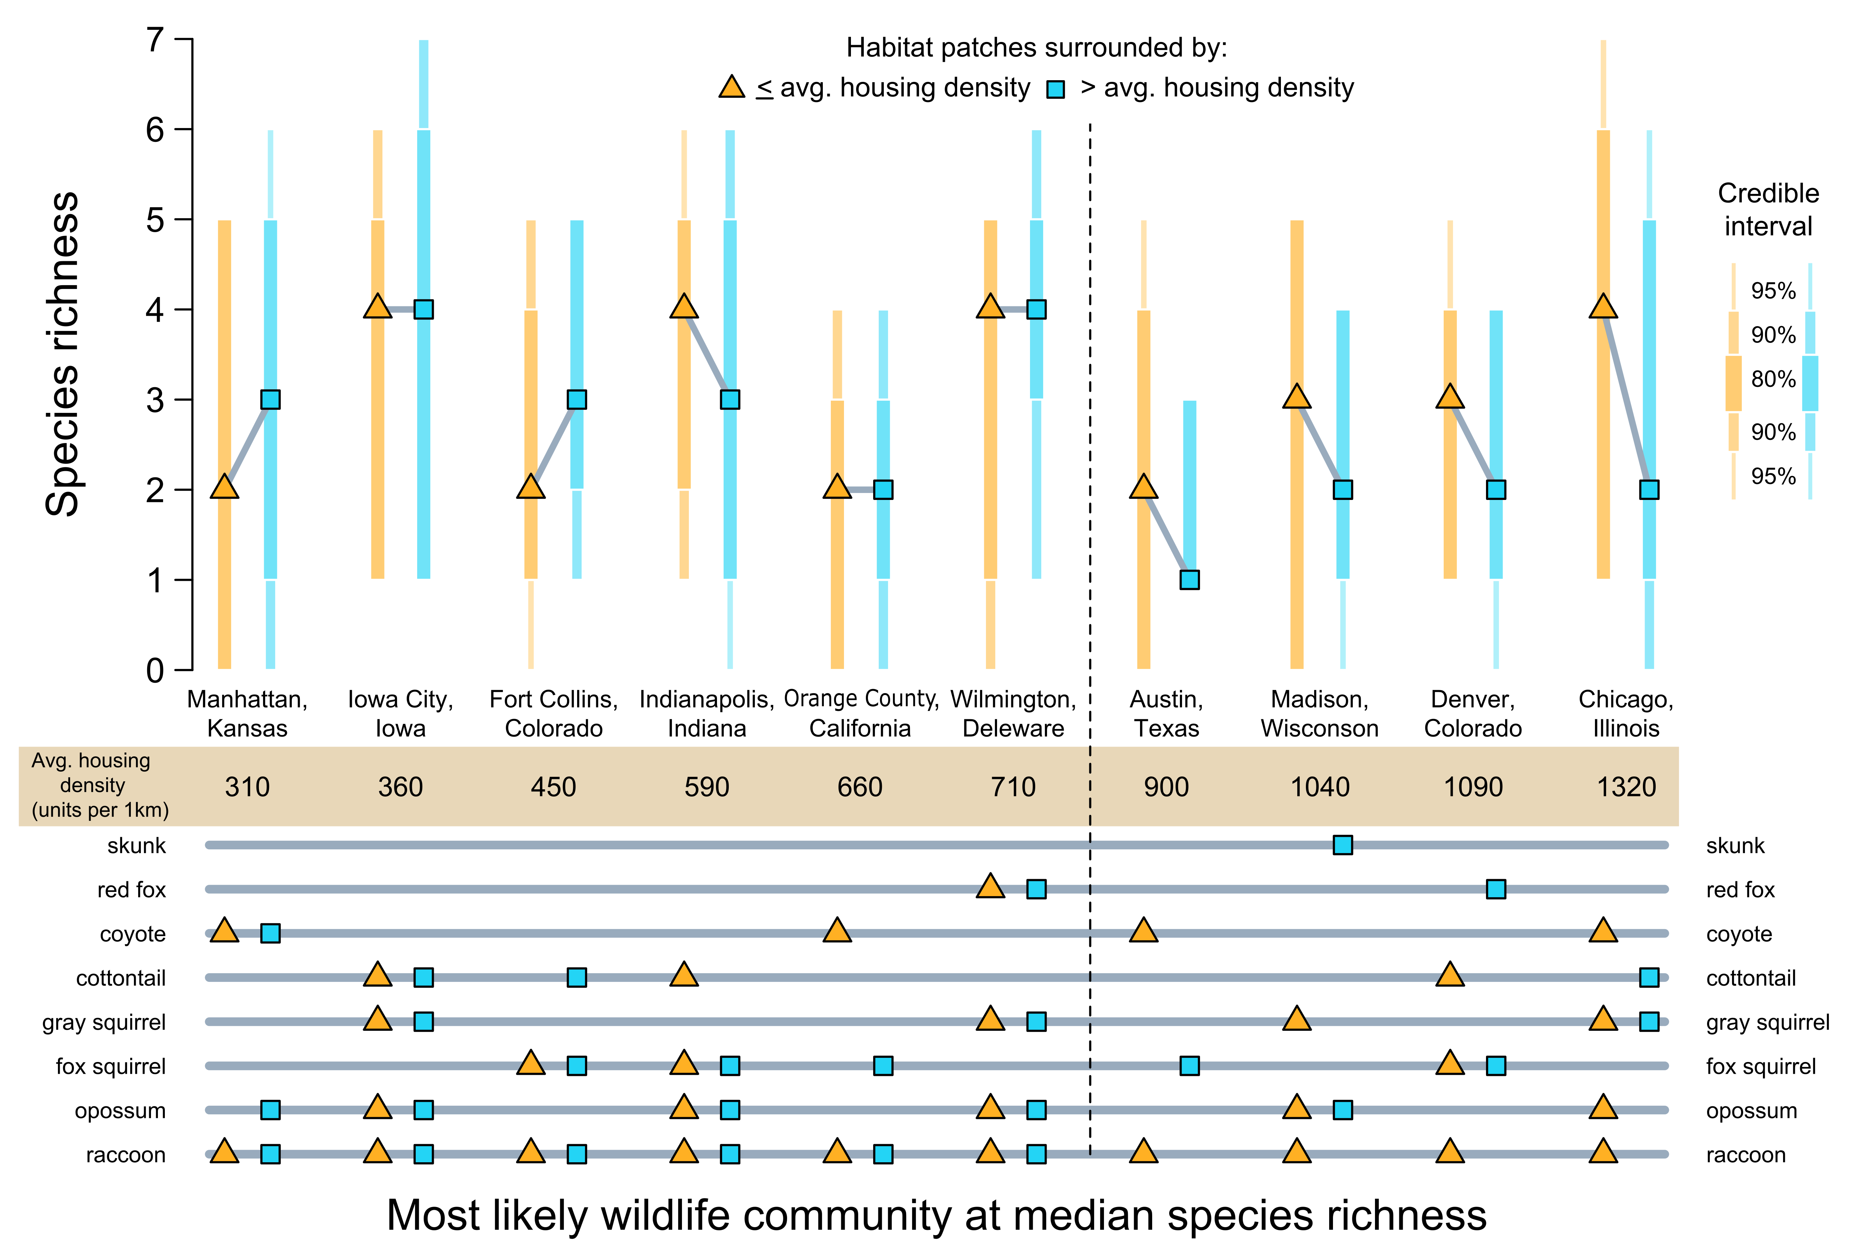

**Fig. 5.** A comparison of the estimated species richness at sites surrounded by less or more than the average housing density in a city. Cities are ordered from left to right, lowest to highest, by average housing density. The lower plot represents the most likely wildlife community represented by the median estimated species richness in urban greenspace in a city surrounded by less than or more than the average housing density for that city. The vertical dotted line represents an apparent shift in differences between species richness: cities with an average housing density > 710 houses km-2 always had fewer species in habitat patches surrounded by dense human populations.

|  |  |  |  |  |
| --- | --- | --- | --- | --- |
| **Table 1**. Model selection results of the four candidate models fit to each species data collected across 10 U.S. cities. Models were compared with the summary statistic $-Σ_{kt}log\left(CPO_{kt}\right)$ for data point *k* and MCMC step *t*, where CPO is the conditional predictive ordinate. Lower values indicate better model fit. The lowest score, which represents the best fit model, is bolded for each species. Species are sorted by their best fit model. | | | | |
| Species | *Mglobal* | *Mhousing* | *Mgreenspace* | *Mnull* |
| Gray squirrel | **2128.28** | 2131.34 | 2128.63 | 2129.17 |
| Coyote | 1211.06 | **1209.59** | 1210.46 | 1215.48 |
| Opossum | 2205.11 | **2204.39** | 2204.95 | 2205.8 |
| Raccoon | 4400.48 | **4399.26** | 4401.09 | 4400.87 |
| Cottontail | 1962.64 | 1962.4 | **1961.38** | 1961.93 |
| Fox squirrel | 1610.9 | 1612.69 | **1610.11** | 1632.01 |
| Red fox | 547.87 | 548.47 | **547.82** | 549.79 |
| Striped skunk | 915.16 | 913.63 | 913.88 | **911.55** |

Supplementary Materials for

Landscape differences among cities alter species’ responses to urbanization

Mason Fidino, Travis Gallo, Elizabeth W. Lehrer, Maureen H. Murray, Cria Kay, Heather A. Sander, Brandon MacDougall, Carmen M. Salsbury, Travis J. Ryan, Julia L. Angstmann, J. Amy Belaire, Barbara Dugelby, Chris Schell, Theodore Stankowich, Max Amaya, David Drake, Sheryl H. Hursh, Adam A. Ahlers, Jacque Williamson, Laurel M. Hartley, Amanda J. Zellmer, Kelly Simon, Seth B. Magle

Correspondence to: [mfidino@lpzoo.org](mailto:mfidino@lpzoo.org)

**This PDF file includes:**

Materials and Methods

Figs. S1 to S2

Table S1 to S2

**Materials and Methods**

Cities

Ten UWIN cities provided data for this study: Austin, Texas; Chicago, Illinois; Denver, Colorado; Fort Collins, Colorado; Iowa City, Iowa; Indianapolis, Indiana; Manhattan, Kansas; Madison, Wisconsin; Orange County, California; and Wilmington, Delaware. The cities are spread across the entire contiguous United States and range from about 43° N (Madison, Wisconsin) to 30° N (Austin, Texas) and 118° W (Orange County, California) to 75° W (Wilmington, Delaware; Fig. S1).

Sites

All cities followed a standard protocol to select sampling locations along a gradient of urbanization (*8*). Sampling locations (hereafter ‘sites’) include an array of potential wildlife habitat such as parks, cemeteries, golf courses, natural areas, and backyards. Transects originated in an urban core of each city and extended outwards through suburban, exurban, and/or rural areas across gradients of impervious land cover and housing density. The average number of sites per city was 51 (min = 23, max = 104). All sites were separated by at least 1 km. This distance was selected because it exceeds the home range extent of most city dwelling mammals surveyed in this study, save for the coyote (*Canis latrans*) and red fox (*Vulpes vulpes*, *36*).

Biological sampling

The focus of UWIN to date has been on passive monitoring of medium to large-sized mammals with motion-triggered trail cameras (hereafter ‘camera traps’). One camera trap was placed at each site for at least 28 consecutive days in January, April, July, and October to capture seasonality in wildlife distributions (*8*). Camera traps were strapped to a tree, fence post, or other object and angled downward so that the camera’s field of view captured another tree or fence post 2.5 – 6 m away. To potentially increase species detectability, a synthetic fatty acid scent tablet (USDA Wildlife Services, Pocatello, Idaho) was placed in a mesh bag and attached roughly 30 cm from the ground to the object, towards which the camera trap was angled.

Photo data were uploaded and processed using a custom Microsoft Access database built for camera trapping research (*37*). A custom R package, ‘uwinr’, was used to check each city’s respective database for errors and to prepare data for analysis (*38*). We generated daily detection histories with these data for each site, species, and sampling season. A detection history took the value of 1 if a species was detected at a site on a given day, the value 0 if a species was not detected on that day, and the value NA if the camera malfunctioned (e.g., batteries ran out) or the camera was not deployed on a given day. For example, the detection history {0, 0, 1, NA} indicates that a species was not detected on the first two days, detected on the third, and then either the camera malfunctioned or was removed on the fourth day. Detection histories were generated with a two-week buffer around each sampling period to account for minor differences in deployment timings between cities.

Data

Most data for this analysis were collected during July 2017. However, two cities contributed data from July 2016 and six cities contributed data from July 2018 (Table S1).

Statistical analysis

We fit a Bayesian hierarchical single-season occupancy model to each species’ data to estimate if their average occupancy probability within a city changed due to among-city differences in greenspace availability and average housing density (*39*). We also quantified relative changes in the likelihood of occupancy along each city’s urbanization gradient (i.e., a species response to urbanization) as a function of among-city differences in greenspace availability and average housing density. Four candidate models were fit to each species’ data to determine the relative influence of our two among-city variables. We explain the global model below. The remaining three models are reduced versions of this global model.

To represent each city’s urbanization gradient, the global model included the housing density (1000 units/km2) within a 1-km buffer around each site. We also included two among-city covariates: overall greenspace availability and average housing density. To calculate overall greenspace availability we first extended the width of each transect in a city by its respective length. A straight 20-km transect, for example, became a square with 20 km-length sides wherein the transect line bisects the center of the square. This method was used to increase the sampled area in proportion to transect length and enabled us to apply a consistent definition of greenspace availability across cities with transects of different lengths. Overlapping squares resulting from multiple transects within a city were spatially dissolved to create a single sampling area. We then calculated the proportion of available greenspace in a city’s study area, following the U.S. EPA’s EnviroAtlas definition (*40*), by combining the forest, herbaceous, shrub & grass, and developed open space (e.g., ,golf courses, cemeteries, parks, etc.) land cover classes from the National Land Cover Database (*41*) and divided the summed area of those classes by the total sampled area for each city. We calculated the average housing density of each city as the mean housing density within a 1-km buffer of all sites in a city from the Silvis housing density data layer (*42*). To estimate if a species’ response to urbanization (i.e., the associated slope term to our ‘within-city’ covariate) changed due to structural differences among cities, we included statistical interactions between our two ‘among-city’ covariates (i.e., overall greenspace availability and average housing density of a city) and our single ‘within-city’ covariate (i.e., the housing density at each site). For a single-species the logit-linear predictor of the probability of occupancy (*Ψjs*) at *j* in 1,...,10 cities and *s* in 1,…,*Sj* sites was

|  |  |  |
| --- | --- | --- |
|  | $$logit\left(ψ_{js}\right)=β_{0j}+β_{1j}\left(hden_{js}-\overline{hden_{j}}\right)+r_{j}+I\left(δ_{j}\right)+I\left(θ_{j}\right)$$ | Eq. S1 |

where

|  |  |  |
| --- | --- | --- |
|  | $$β_{0j}=γ_{00}+γ_{01}greenspace_{j}+γ_{02}\overline{hden_{j}}$$ | Eq. S2 |

and

|  |  |  |
| --- | --- | --- |
|  | $$β_{1j}=γ_{10}+γ_{11}greenspace_{j}+γ_{12}\overline{hden_{j}}$$ | Eq. S3 |

In Eq. S1, $β_{0j}$ represents the average log-odds species *s* occupies an average site in city *j* and can be biologically interpreted as a species average occupancy probability within a city*.* It is derived from the intercept term $γ_{00}$ and the effect of the two between-city covariates – overall greenspace availability (${greenspace}_{j}$) and the average housing density of a city ($\overline{hden_{j}}$) via Eq. S2. Among-city covariates were centered and scaled to have a mean of 0 and standard deviation of 1. $β_{1j}$ is a slope-term that represents the relative log-odds change in occupancy at city *j* and site *s* given the within-city site-level housing density covariate, ${hden}_{js }$, and can be biologically interpreted as a species response to urbanization. Unlike the among-city covariates, ${hden}_{js }$ is group-mean centered by subtracting the respective city average, $\overline{hden_{j}}$, from each ${hden}_{js}$. This scaling eases model interpretation and ensures the slope terms in Eq. S2 and Eq. S3 (i.e., $γ_{01}, γ_{02}, γ_{11}$ and $γ_{12})$ represent among-city effects (*43*). As with $β_{0j}$, $β_{1j}$ is allowed to vary in magnitude or direction via Eq. S3 as a function of the two among-city covariates. By algebraically inputting Eq. S2 and S3 into Eq. S1 it is evident that the parameters $γ_{01}$ and $γ_{02}$ are slope terms that vary by city while $γ_{11}$ and $γ_{12}$ are interaction terms between our among- and within-city covariates.

To account for additional among-city variation we included a city-specific random effect ($r_{j}$; Eq. S1). We also accounted for multiple years of sampling with two indicator functions, $I(δ_{j})$ and $I(θ_{j})$.The parameter $δ_{j}$ is the log-odds difference in average occupancy at city *j* in 2016. If a city had 2016 data this term was estimated, otherwise it was 0. Conversely, $θ_{j}$ is the log-odds difference in average occupancy at city *j* in 2018 if and only if city *j* had 2017 data. For the detection model we allowed the species-specific detection probability ($ρ_{sj}$) to vary among cities such that the logit-linear predictor was $logit(ρ_{sj}) = a_{0} + a_{j}$ where $a_{0}$ is the average log-odds of detecting a species while $a_{j}$ is a city level random-effect.

Model set, prior specification, and model selection

The four candidate models fit to each species’ data differed in the number of among-city variables (Eq. S2) and represented separate hypotheses about which differences in urban form among cities were correlated with the average occupancy of a species in a city (Eq. S2) or where a species was most likely to occur within a city (Eq. S3). The global model ($M_{global}$) described above contained both among-city variables, our greenspace model only included the proportion of greenspace in a city ($M_{greenspace}$), and our housing density model only included the average housing density of a city ($M_{housing}$). We also included a null model that contained no among-city variables ($M_{null}$). All models included the site-level housing density covariate (${hden}_{js }$; Eq. S1), which represents the urbanization gradient in each city, and used the same detection model. Cities that were outside the distributional range of a species were omitted from that species’ analysis, and models were only fit to a species’ data if they were detected at a minimum of five participating UWIN cities (50% of sampled cities).

We used a Bayesian framework to parameterize and evaluate our models. All logit-scale parameters, save for the random effect terms, were drawn from Logistic(0,1) distributions which represent a vague logit-scale prior. Random effects were drawn from N(0,σ) distributions where σ ~ Inv-gamma(0.001, 0.001). To compare the relative fit of each model we calculated the conditional predictive ordinate (CPO) of each data point at each MCMC step (*44*). Overall model performance was evaluated with the summary statistic $-Σ_{kt}log({CPO}_{k,t})$ for data point *k* and MCMC step *t* and the lowest value indicates the best relative fit (*45*). Models were fit in JAGS version 4.3.0 (*46*) via the R programming language version 3.5.3 (*47*). After a 60,000 step adaptation and 60,000 step burn-in, each model was sampled 1,250,000 times across 5 chains. Due to the computational intensity of tracking the CPO of each data point, chains were thinned by 10 for a total of 125,000 samples. To verify model convergence, we ensured that Gelman-Rubin diagnostics for each parameter were < 1.10 and examined trace plots of parameters from the MCMC chains to visually confirm proper mixing (*48*). While the number of parameters could differ for the best-fit model of each species, we referenced parameters as we did for the global model (i.e., Eq. S1 – S3) for consistency.

Quantifying species richness within and among cities

We used posterior simulations of species occurrences from each species’ best-fit model to derive 1) within-city species richness at sites surrounded by less than or more than a city’s average housing density and 2) the most likely wildlife community to occur at the estimated median species richness.

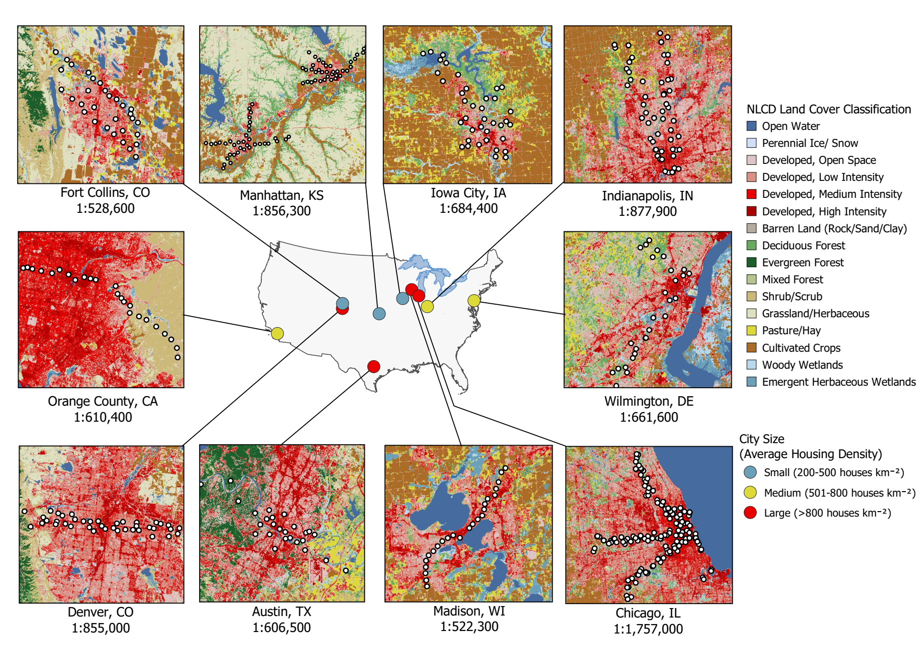

**Fig. S1.** Map of the ten cities sampled for this analysis. White dots within each subfigure represent camera trapping sites. Landcover images derived from the National Landcover Database.

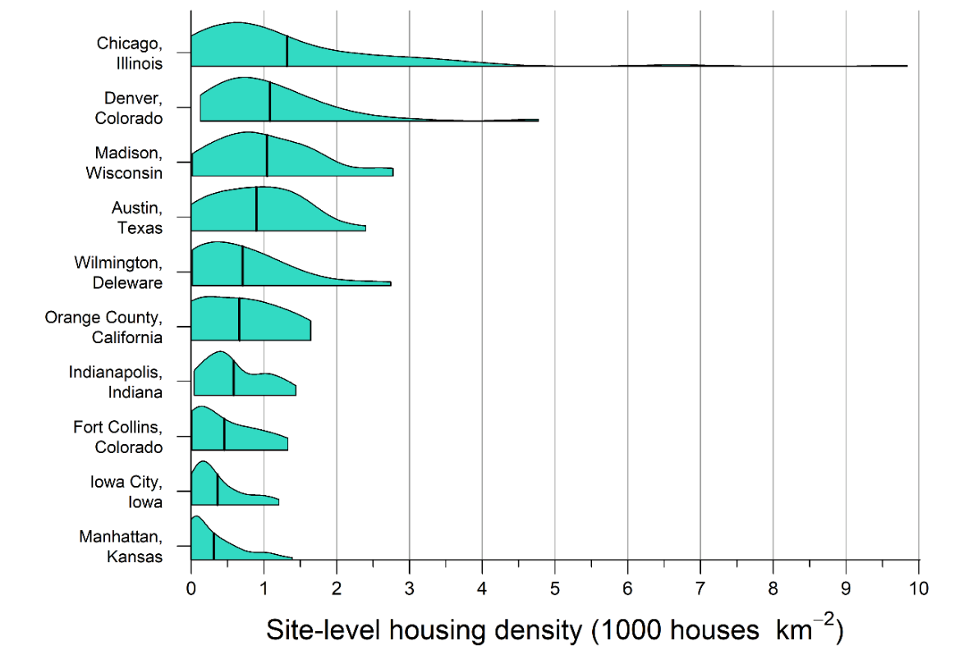

**Fig. S2.** The range and extent of within-city housing density measured at camera trap locations of 10 U.S. cities. Black vertical bars represent the mean housing density across all locations within a city. Housing density was calculated within a 1 km buffer of each camera trap location.

|  |  |  |  |
| --- | --- | --- | --- |
| **Table S1.** The number of functional sites with classified data per year and city. A dash indicates data were not available. | | | |
|  | Number of sites sampled | | |
| City | 2016 | 2017 | 2018 |
| Austin, Texas | - | 25 | - |
| Chicago, Illinois | 97 | 104 | 100 |
| Denver, Colorado | - | 40 | - |
| Fort Collins, Colorado | - | 31 | - |
| Iowa City, Iowa | - | 37 | 39 |
| Indianapolis, Indiana | - | 45 | 43 |
| Orange County, California | - | - | 24 |
| Manhattan, Kansas | 74 | 74 | - |
| Madison, Wisconsin | - | 23 | 24 |
| Wilmington, Delaware | - | - | 28 |

|  |  |  |
| --- | --- | --- |
| **Table S2**. The among-city covariates calculated for each of the 10 U.S. cities where camera trap data was collected. Cities are sorted by mean housing density. | | |
| City | Greenspace availability  (proportion) | Average housing density  (houses km-2) |
| Manhattan, Kansas | 0.63 | 310 |
| Iowa City, Iowa | 0.31 | 360 |
| Fort Collins, Colorado | 0.44 | 450 |
| Indianapolis, Indiana | 0.29 | 590 |
| Orange County, California | 0.42 | 660 |
| Wilmington, Delaware | 0.51 | 710 |
| Austin, Texas | 0.59 | 900 |
| Madison, Wisconsin | 0.24 | 1040 |
| Denver, Colorado | 0.39 | 1090 |
| Chicago, Illinois | 0.18 | 1320 |